Frequently asked questions
What are the manager’s responsibilities when using the company credit card?
- Create a P.O. in Isis for items being purchased
- Update the Wells Fargo Web site with the following info
  - P.O. number (same as Isis p.o.)
  - Add description of purchase
  - Upload receipt image( either thru ceo mobile app, or via fax)
- Review and update transactions weekly, and submit for Regional approval.

How do I create a P.O. in Isis when using my credit card as payment?
- Create a po as you would normally, then select vendor you are purchasing from. Use a buymisc to load part and make sure cost and description is loaded correctly. You will also need to ref invoice where parts are being sold on and add plenty of notes stating that purchase was made using credit card.
- If vendor is not loaded in Isis. Use WELLS FARGO CC VENDOR #70000702 as vendor. (use CREDITCARD as a shortcut) Again make sure there are plenty of notes (same as above). This time you will also need to add name of vendor purchasing from.
How do I update the Wells Fargo web site?
- Go to wellsfargo.com
  - Select commercial, then sign in using TAPWO220 as company ID. (note difference between O, and zero)

  - Select
  - Select View Cycle-to-Date
  - Then select one of the two credit cards
(note. transactions can take 2-3 days to post on to wells fargo)
You will then be shown a list of all the credit card transactions posted in the system.
Check the box next to the transaction and select reclassify. This will allow you to input a po #, inv #, and a description of items purchased.
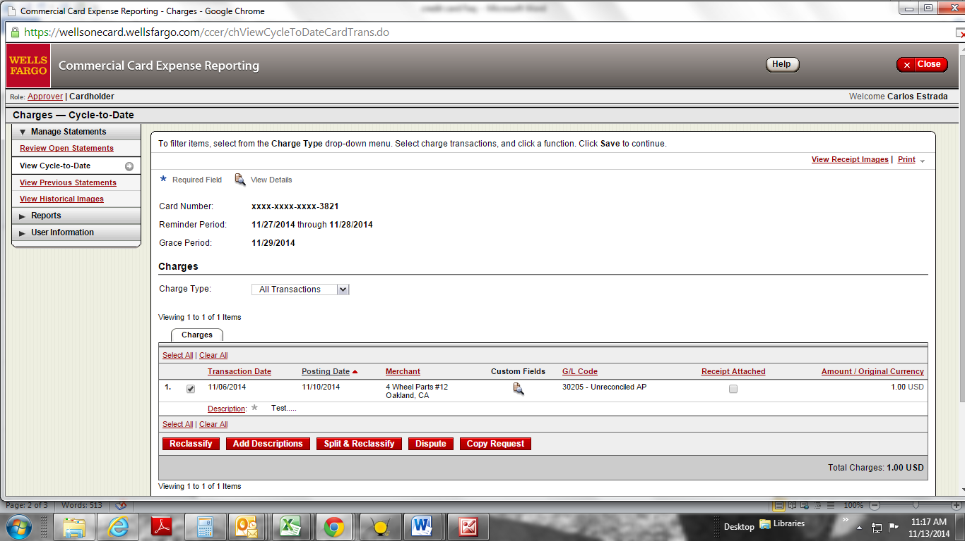
- How do I upload Receipt to Wells Fargo site?
  - There are two ways that you can upload the receipt. Easiest way is using the CEO Mobile app on your cell phone this will also link up to this account. Or you can print a fax cover sheet from the website and fax it into Wells Fargo.
( in the above screen shot. Select Print in upper right hand)
What can I purchase with the company credit card?
- At this point, you can only purchase items that will be resold.
What is my monthly Limit?
- $1500.00 monthly amt. If you need to exceed that amt, contact your regional mgr.
What if the transaction gets declined?
- There are parameters set within our credit card that will only allow us to do business with certain types of vendors. If a transaction gets declined, that vendor type may not be within the parameters. Please contact Art Baez Abaez@4wheelparts.com and he can make the necessary adjustments.
How long does it take for a transaction to post to account?
- Usually post with 2-3 business days
Step 1
Frequently asked questions
- See the attachment FAQ documents

Step 2
General Credit card questions (just like your personal credit card)
- 800-932-0036

Step 3
Credit limit increases or to approve usage with a vendor
- Michelle Chirrick mchirrick@4wheelparts.com
- 310-900-5500 X5300

