March 2016 Pricing Updates

- All discounts will be pulled out of all retail AD codes (ORA0216)
- All discounts will be a manual override to get to a promo or web price
- Salespeople will be able to manually override to get to a promo or web price
- Manual overrides will go up
- AD code discounts will go down and eventually to zero
- Overall discounts will go down

How to identify an item on promo
Not on Promo On Promo
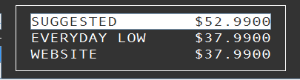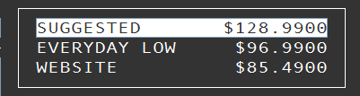

Lets show the savings

AD codes replacing the ORA AD code
DIR DIRECT MAIL ADVERTISING
WEB WEBSITE ADVERTISING STORE
SOC SOCIAL MEDIA ADVERTISING
RAD RADIO ADVERTISING STORES
PRI PRINT ADVERTISING STORES
WALKIN CUSTOMER WALKIN STORES
AD codes will be used to track what brought customer in, not to drive discounts

