Service & Technician
Bulletin

Brake Hose Failure Prevention Safety

When installing a suspension kit or doing any type of repairs requiring caliper removal, it is mandatory that we support the weight of the brake caliper by a hook, heavy gauge zip tie, bungee cord or other type of support device. NEVER ALLOW THE CALIPER TO HANG BY THE BRAKE HOSE! Allowing the caliper to hang by the brake hose could cause damage permanent, invisible damage to the brake hose which could result in a brake failure.

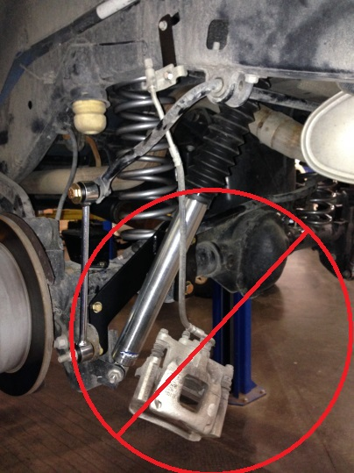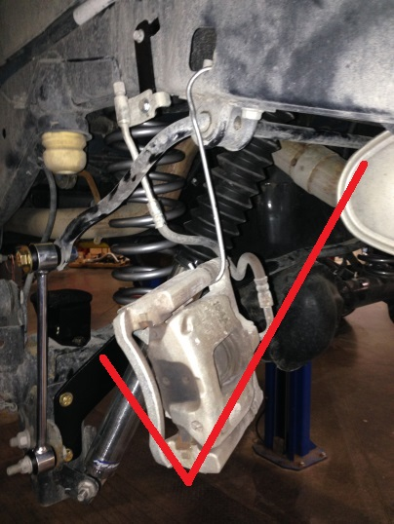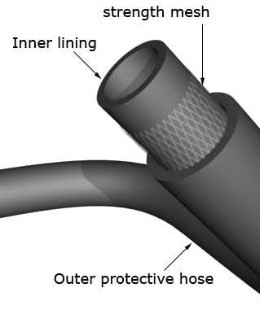

WRONG! Right Typical Brake hose

Some of the brake calipers we handle are very heavy. The stretching of the hose could pull against the expansion windings inside the hose and cause a break in the cords or could partially collapse the inner liner of the hose inside the cords (where you can’t see the damage). A disruption in these internal parts of the line could cause uneven braking or even complete fluid blockage even under hard braking. This could cause 2 separate problems. #1 is not allowing fluid to reach the caliper at all. #2 is not allowing pressure to escape from the caliper and keeping the brakes partially engaged on one side. Neither result is desirable SO DON’T DO IT!

Work smart. Hang those calipers. Prevent problems BEFORE they happen.

EQP 2014

