Wiring a 2005 and Up Ford Superduty Using
The Factory Installed Switches

Many Customers ask us to wire lights on their vehicle using the factory installed toggle switches (or the auxiliary switches). Most of the new Coil Spring Ford Superdutys will come with four factory installed auxiliary switches located next to the factory installed brake controller. We have found that the switches are wired with relays ready to be used. Ford has made it really easy for us to wire customers’ lights now.

- First remove the plastic panel located under the steering column to expose the fuse panel (or fuse block).
- Remove the black cover on the fuse panel to expose the fuses.
- Remove the four 6mm bolts that hold the fuse panel in place; it will require a 10mm socket. (Fig 1)
- Once the fuse panel is loose, there is enough slack to pull the fuse panel down about 10 to 12 inches.
- Located on top of the fuse panel you will see a cluster of wires. There will be four wires labeled AUX switches. The 12ga wire that is orange with a green stripe is for the #1 Aux switch. The solid orange 12ga wire is for the #2 Aux switch. Both Aux #1 & 2 are on a 30 amp relay (each have their own relay). The orange 18ga wire with a yellow strip is for Aux #3, and the orange 18ga wire with a blue strip is for Aux #4. Both Aux 3 & 4 are on a 15 amp relay (each have their own relay). If you’re going to wire huge lights on the front bumper, use the Aux 1 & 2 switches since they use 12ga wires and a 30 amp relay. (Fig 2)
(Note the four auxiliary wires will have a heat shrink tube over the end of them from the factory, since they are hot. This will help you locate them easier.)
- To help in wiring the lights – for some reason Ford has four 16ga wires pre-run through the fire wall of the truck – so no drilling or fishing the wires through the fire wall is necessary. The wires are located next to the brake master cylinder under the hood. They will be taped to a large wire loom, and they are red, blue, black and white. When you have the fuse panel down, you will see them under the dash located next to the panel. There is enough slack to attach them to the auxiliary wires, and then you will have power under the hood ready to hook up to the auxiliary lights you just installed on the customer’s truck.

It doesn’t get any easier than that. So the next time you have a customer ask you to wire his lights using his auxiliary switches go for it. Only don’t give the labor away just because it’s an easy job; remember they pay us for a service because we know what we are doing!

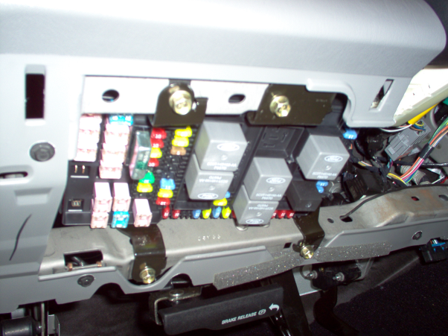
Fig 1

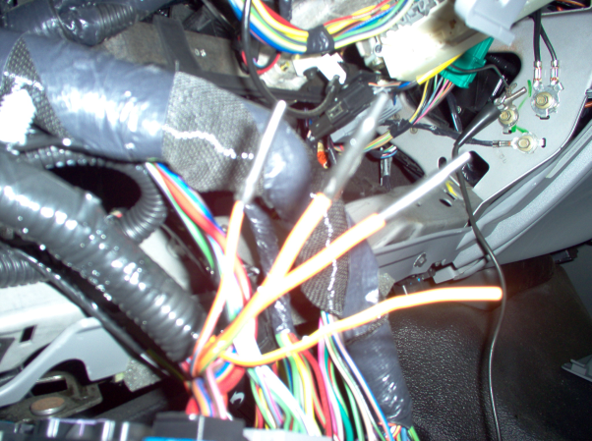
Fig 2

