

Service & Technician

Bulletin

Service 0111 DIVISION NUMBER

TO: All Sales and Service

FROM: Service Operations

DATE: April 9th. 2008

SUBJECT: Toyota FJ Cruiser/ARB Bull Bar Part # 3420100 Install

When installing the ARB Bull Bar on the Toyota FJ **“YOU MUST”** check to see that the AC line does not make contact with the Bull Bar brackets. You will be required to make a slight bend in the AC line per the ARB instructions; you will also need to install a rubber hose over the line to help prevent any rubbing. Take a rubber fuel line and cut it down the middle, place a zip tie on each end to secure it in place. See the attached photo. Step 14 and 15 from the ARB instructions has also been attached to the TSB.

14. Fit the chassis mount bracket to the chassis using the original flange nuts removed with the bumper reinforcing bar. Centre the chassis mount bracket and tighten.

***CAUTION: When fitting the Chassis mounting bracket carefully bend the air-conditioning pipe out of the way.***

15. If required, carefully bend piping clear of mount bracket assembly, with **a minimum clearance of 20mm (3/4”).**

***CAUTION: Piping must not rub on sharp edges, secure with cable tie and protective sheath if required.***

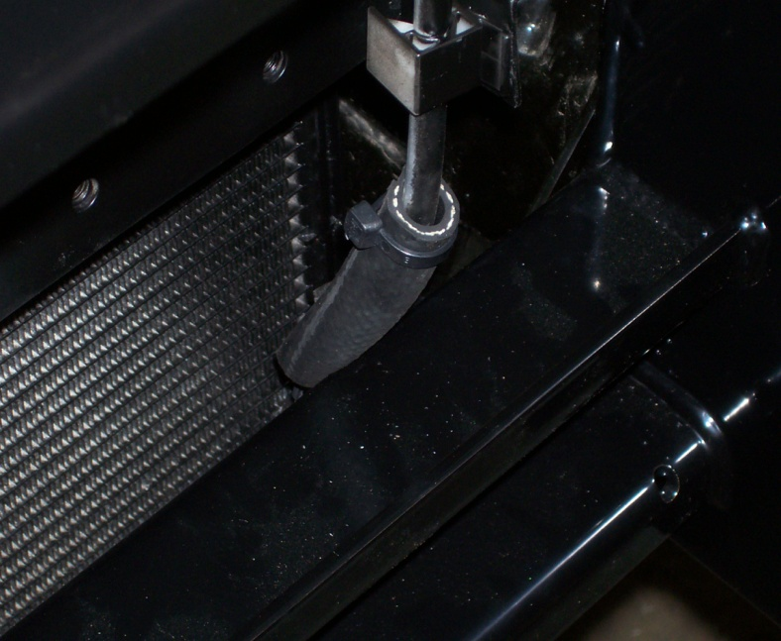

If you have any questions, contact your Regional Service Manager.