12/4/12
Tech Tips
Dynatrac Ball Joints
The Dynatrac Ball Joint JP44-2X3050-A is designed to be used in a Dana 44 JK axle, other manufactures such as Dana Spicer, Moog and Crown offer a ball joint set that will work in both Dana 30 and Dana 44 JK front housings. The Dynatrac lower ball joint will make contact with the axle shaft when installed due to it being taller than the OEM ball joint.
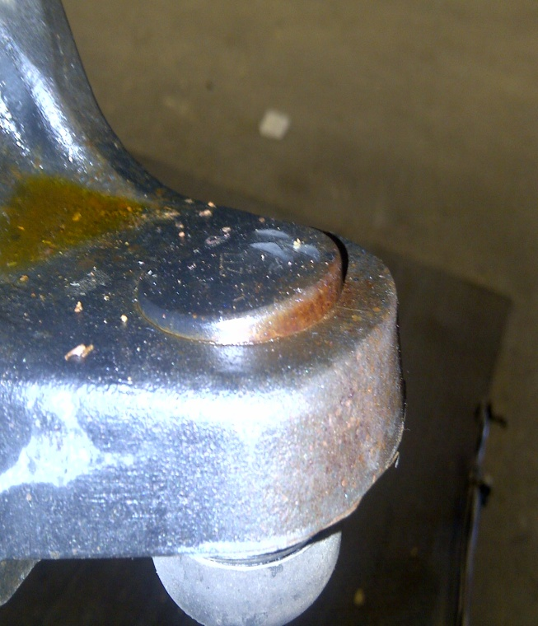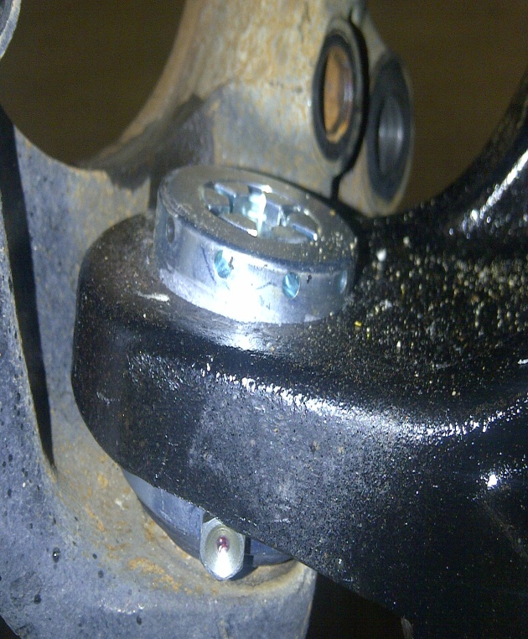
OEM Dana 30 Ball Joint Dynatrac Ball Joint Installed

