Service & Technician
Bulletin

Block Kits

When installing a suspension kit it is always important to read the instructions, Pro Comp as well as many other manufacturers will often make items that fit more than one application. With that being said Pro Comp makes some rear lift block kits that works with traction bars and non-traction bar applications. When installing a lift block kit it is important check the center pin in the block and make sure the lower pin on the block does not bottom out on the axle tube when placed on the axle pad. It may be necessary to grind the block center pin down as per the Pro Comp instructions.

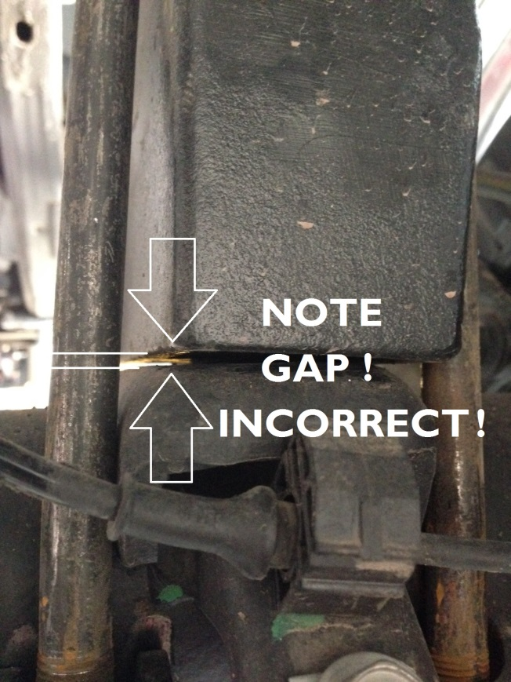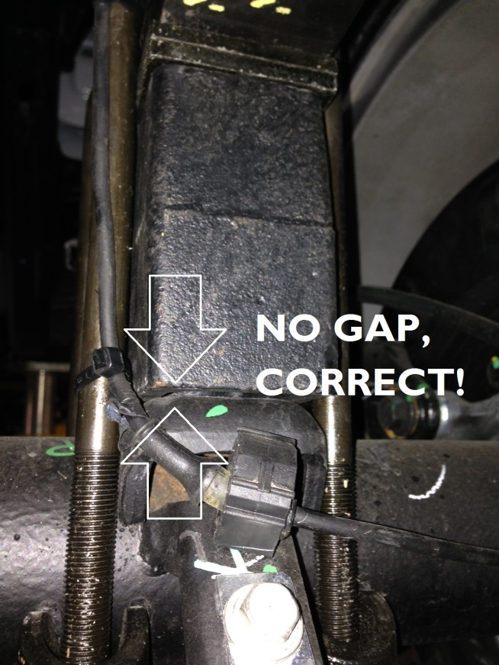

Work smart and always read the instructions first!

EQP 2014

