Steel wheel inspection/leaking stems

It has come to our attention that some brands of steel wheels may have an issue right out of the box that could allow leaks from the valve stems. Close inspection visually or with a soft touch from your finger may reveal that the bottom edge of the valve stem hole has a sharp edge left behind from when the wheel was made. This sharp edge can cut the valve stems during installation or even wear the stem enough over time to cause leakage.

A quick touch up with a de-bur tool or even emery cloth can knock the sharp edge off and save you from having to service it again. See below.

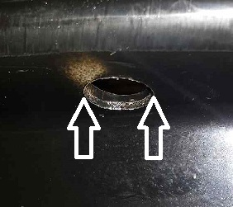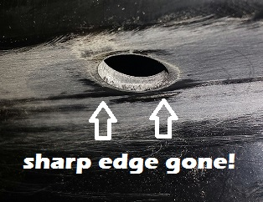

Look out for the sharp edge, remove it, lubricate the stem when installing. It’s easy.

Work smart, be alert, and save yourself the trouble later!

JRM 2014

