Processing Synchrony Transactions
Overview:
- What is Synchrony?
  - Synchrony financial is a third party credit service we offer to our customers via their Car Care Credit Card. (Reference monthly Ring codes for current promos, Example 12 months 0%)
- Where to process charges?
  - (1) Directly through Synchrony’s website : businesscenter.mysynchrony.com/BusinessCenterPortal/
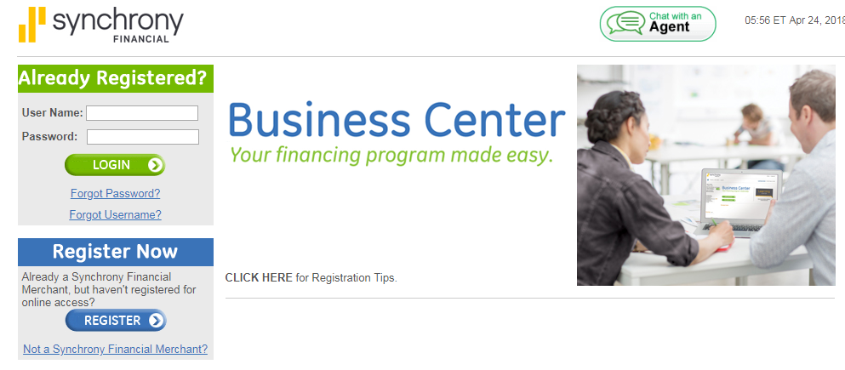
    - Unlike Visa/MC/AMEX/DIS; which are charged directly through our Point of sale System (Legend) using Ingenico payment terminals, Synchrony is not linked to our system; this is why you must run the card through Synchrony’s website.
  - (2) Login to the Business Center Website with your stores Login Info and choose “PROCESS A SALE” (Contact your Regional mgr. if you need help obtaining your store login)
  - (3) Choose your Transaction type. (PURCHASE and REFUND being most common)
  - (4) After filling out customer info, dollar amount, Promo Code, Invoice Number, etc. Click Submit (Ref Ring Codes for current Promo code- If no promo code just type 000 to default to standard rate)
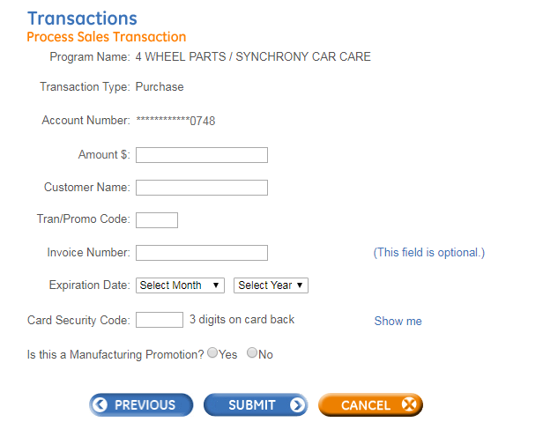

- (5) Have your customer sign one copy of the receipt and attach the signed copy to your 4 Wheel Parts invoice and file with the days paperwork

The Transaction is still not completed- YOU must now process the Transaction in our Point of Sale System (Legend)

  - (6) After processing a transaction through Synchrony, you must also manually process the transaction through our Point of Sale system. (Legend)
    - Proceed to the Manual Payment close out screen (Enter Car Care Credit Card number and transaction amount that was charged on the Business Center Website)

  - (7) MAKE SURE TO ENTER THE TRANSACTION AUTHORIZATION (Approval) NUMBER that was generated on the Synchrony website in section 18
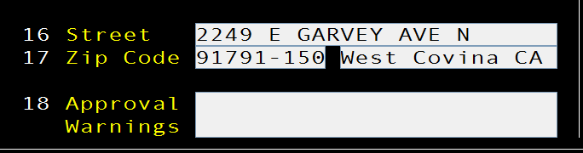

  - (8) Close the invoice and attach printed copy with the Synchrony Transaction you printed out earlier. File both with your Daily Paperwork

SYNCHRONY TRANSACTION NOTES

Things to Remember
- Andromeda Reporting:
  - Always DOWNLOAD and PRINT your Credit Card Transactions for the day on the Business Center Website every night before you close books
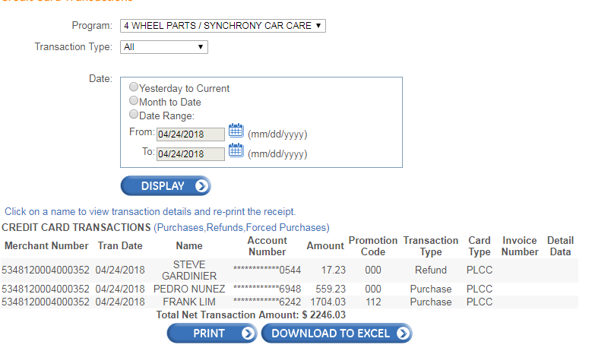
  - On-line web orders
    - (1) If a Synchrony on-line web order is received WITHOUT the Deposit attached, then you must process the Order in LEGEND ONLY! (The card has ALREADY been charged through Synchrony; BUT we must CHARGE the card in LEGEND so we have a Deposit)
    - (2) Synchrony and Legend are not linked. This is why it is ok to run through Legend only.
    - (3) Your Andromeda totals WILL BE OFF. THIS IS OK! You will be OVER on Legend (Right) side of Tally, and SHORT on the Bank (Left) side of the Tally.
      - Put a note for the transaction details referencing the Invoice number.
        - Ref picture on NEXT PAGE
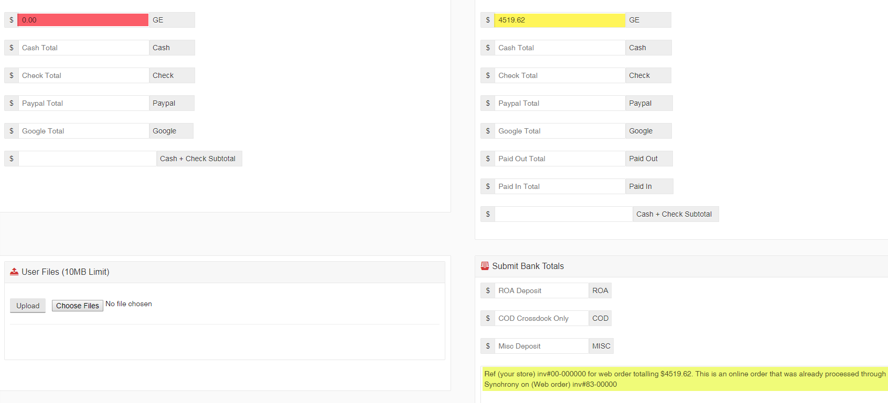
Remember: It is ok for your Andromeda TOTALS to be OFF when due to an Internet Order. You MUST put NOTES referencing BOTH invoices (Your store and the Web Order). That way accounting can balance company totals.
However, ANY Synchrony transaction performed directly in your store MUST be ran through Synchrony and Legend EVERY TIME!

