Procedure: All 4WP Retail locations will follow daily, weekly and monthly COVID-19 processes to ensure a safe and healthy environment for all employees and customers. This procedure will minimize exposure and maximize the safety of each 4WP location. Weekly and monthly audits will be performed by Store Management to document all steps taken while identifying opportunities and actions taken to address them.
DAILY RESPONSIBILITIES
- Employee
- Required to be compliant with all current training modules related to COVID-19.
  - COVID-19 Training
- Must be wearing facemasks prior to entering the building or at the pre-designated area.
  - Face Mask Proper Use Guideline
  - Polaris How to Use a Face Mask
- Must have their temperature checked by Store Management at the beginning of each shift.
  - Store Management
- Conduct temperature check on each employee at the beginning of their shift using the “Temperature Screening Guide”
- Temperature Screening Guide
- Operating the Infrared Thermometer see Example 1.1
- Measuring forehead temperature see Example 1.2
- If employee temperature reads below 100 degrees (Fahrenheit), follow the steps detailed in the “Infrared Thermometer KF30 Operation Manual”
- Infrared Thermometer KF30 Operation Manual
- Clean and store unit see Example 1.3
- Clean the temperature probe
- Place thermometer in a dry well-ventilated location
- Replacing thermometer batteries see Example 1.4
- When unit indicates battery power is at 50% purchase replacements at a local retailer
- Unit requires (2) AAA batteries
- If employee temperature reads 100 degrees (Fahrenheit)or above (after 2 screenings
- Must complete COVID Symptom Assessment on each employee at the beginning of each shift.
  - COVID Symptom Assessment
- Ask employee “In the last 24 hours have you experienced signs and symptoms associated with COVID-19, and/or in the last 14 days have been directly exposed to someone with COVID”
  - Complete the Employee Suspected Flu Notification with the employee then email the completed form to hr@4wp.com and ehs@polaris.com
- Advise employee to contact HR and seek medical guidance.
- Employee will be sent home and not be returned to work until results are reviewed and return to work approved through HR.
- Compliance: TAP COVID guidelines followed.
- Facility maintenance/Personal hygiene
- Maintain supply of:
- Disposable masks order through RSM
- Hand sanitizer order through RSM
- Disinfectant wipes order through RSM
- Hand soap order through UniFirst
- Preparing our Stores for Social Distancing
- Maintain supply of:
- Yellow plastic caution tape purchase at local home improvement store
- Reflective floor stickers purchase at local home improvement store
- Supplement to Social Distancing
- Plexiglass “sneeze guards” - Additional supplies can be purchased to construct additional if needed purchase from local home improvement store.
- Plexiglass
- Hanging chain/rope
- Small carabiners
- Social Distancing Signage
- Temporary Visitor Guidelines
- Applies to all vendors, technicians or visitors performing work at a 4WP facility
- Must follow all Social Distancing guidelines
- Minimize interactions with 4WP employees
- Clean and disinfect workstation at the end of each workday
- Practice good personal hygiene
- All other regularly required PPE
- Compliance: Ordinance Jurisdiction Local/State; example:
- Store Occupancy Limits
- Must know current status of any Local or State ordinances regarding occupancy limits
- Update signage to reflect any occupancy limits
- 4WP – Store Occupancy Sign
Note: Any questions must be directed to HR hr@4wp.com or EH&S ehs@polaris.com
  - Regional Management
- Contact assigned store grouping confirming daily protocol by 8:50AM local time.
- Action plans Store specific needs/compliance concerns
- Confirm completion via text or email to Zone Manager.
  - Zone Management
- Confirm completion via text or email to Store Operations.
WEEKLY RESPONSIBILITES- Every Friday, the weekly checklist will be available in the 4WP Toolbox www.4wptoolbox.com (the monthly checklist will replace the weekly on the final Friday of each month)
Store Management - (Store Manager, Assistant Manager or Service Manager)
- Access the 4WP Toolbox
- Enter the password – see Example 2.1 (the password is updated every Friday and available in the “Friday Live” email).
- From the “Home” page of the Toolbox select the “Daily Compliance Audit” button. See Example 2.2
- The “Daily morning meeting training” document will appear
- Navigate to the current day shown on row 2 of the document
- The Friday cell will have a light background with blue text
- Click on the cell on row 2 with the current date see Example 2.3
2.1 The “Weekly COVID Audit” SharePoint document will appear containing 10 observation areas. See Example 2.4
- Entries to the audit will be made directly into the SharePoint document or by opening the document in the “Desktop App”
- To open in the “Desktop App” click on “Open in Desktop App” see Example 2.5
2.2 Entries will be made in the “Weekly COVID Audit” document for each area found in column “B”
- “Employees are entering and exiting through the designated entrances, are temperature screened, asked Symptom Assessment screening form questions & everyone is maintaining 6ft. of social distancing?”
  - Based on observations since the date of the prior Weekly Audit
- 100% compliance with all areas of observation = Yes
- Less than 100% compliance in any area of observation = No
- Repeat Step 1 for areas 2 through 10
2.3 Making entries in the SharePoint document
- Navigate to your store (located on line 7 of the document)
- Click on the box on row 10 directly below your store number and a “Dropdown” arrow will appear. See Example 2.6
- Click on the dropdown arrow then select the appropriate response to the question in column “B”
- Repeat this for lines 11 through 19
- When all observations have been entered, the employee performing the audit will enter their initials on line 20 in the row corresponding to their store see Example 2.7
- Comments will be entered into rows 23 through 115 corresponding to the store being reviewed
- Comments must be entered for all areas with a “No” in rows 10 through 19
- What corrective actions will be taken to address the failure?
- What was observed that might lead to a future failure and how will it be corrected?
- What changes were made that corrected a previous failure?
Note: When making entries in the “Desktop App”, ensure that “AutoSave” is set for “On” see Example 2.8
- If the document is not set to “AutoSave”, “save” the document when complete see Example 2.9
Regional Management
2.4 Review Weekly COVID Audit Results
- Create Action Plans to address deficiencies and commentary
- Complete the weekly Regional Store Ownership-COVID tracker
- Communicate Action Plans to Zone Management as required
Zone Management
2.5 Confirm Completion Via Email to Store Operations
MONTHLY RESPONSIBILITIES – will be assigned and completed the final Friday of each month in place of that week’s weekly audit.
Store Management
- A Member of Store Management (Store Manager, Assistant Manager or Service Manager) will login to the 4WP Toolbox
- Enter the password (the password is updated every Friday and available in the “Friday Live” email).
- From the “Home” page of the Toolbox select the “Daily Compliance Audit” button.
- The “Daily morning meeting training” document will appear
- Navigate to the current day shown on row 2 of the document
- The Friday cell will have a light background with blue text
- Click on the cell on row 2 with the current date
3.1 The “Monthly COVID Audit” SharePoint document will appear containing 14 observation areas. See Example 3.1
- Entries to the audit can be made directly into the SharePoint document or by opening the document in the “Desktop App”
- To open in the “Desktop App” click on “Open in Desktop App” see Example 3.2
- Entries will be made in the Weekly COVID Audit” as described below
- “Protocols are in place encouraging ill employees not to come to work? (Signage and Training)?”
  - Based on observations since the date of the prior Weekly Audit
- 100% compliance with all areas of observation = Yes
    - Less than 100% compliance in any area of observation = No
- Repeat Step 1 for areas 2 through 10
  - Making entries in the SharePoint document
- Navigate to your store (located on line 7 of the document)
- Click on the box on row 10 directly below your store number and a “Dropdown” arrow will appear.
- Click on the dropdown arrow then select the appropriate response to the question in column “B”
- Repeat this for lines 11 through 23
- When all observations have been entered, the employee performing the audit will enter their initials on line 24 in the row corresponding to their store
- Comments will be entered into rows 27 through 119 corresponding to the store being reviewed
  - Comments must be entered for all areas with a “No” in rows 10 through 24
  - What corrective actions will be taken to address the failure?
  - What was observed that might lead to a future failure and how will it be corrected?
  - What changes were made that corrected a previous failure?
Note: If the document was opened in the “Desktop App”, ensure that “AutoSave” is set for “On”
- If the document is not set to “AutoSave”, “save” the document
Regional Management
3.3 Review Weekly COVID Audit Results
- Create Action Plans to address deficiencies and commentary
- Communicate Action Plans to Zone Management as required
Zone Management
3.4 Confirm Completion Via Email to Store Operations

Responsibilities: Failure to follow any/or all guidelines listed above will result in further disciplinary actions up to and including termination. Discipline will be applied to all who participated in the unapproved activity (salesperson, technician, service manager and/or retail manager)
Example 1.1
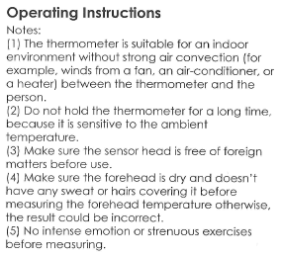
Example 1.2
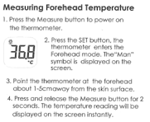

Example 1.3
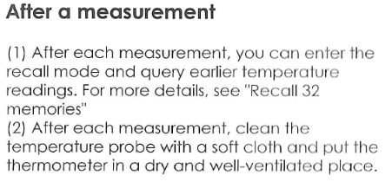
Example 1.4
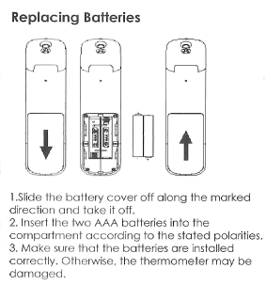

Example 2.1
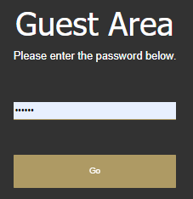
Example 2.2
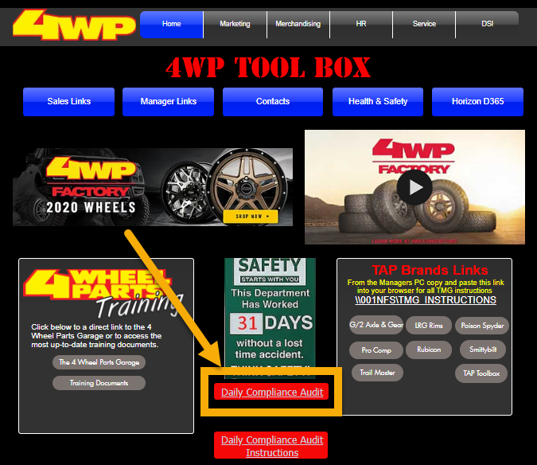

Example 2.3
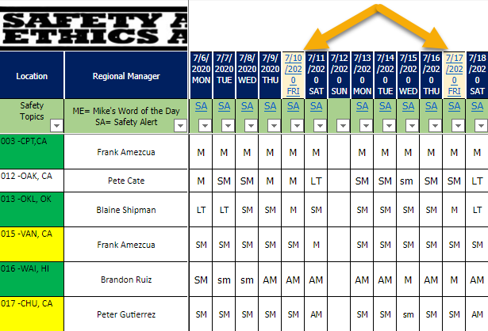
Example 2.4
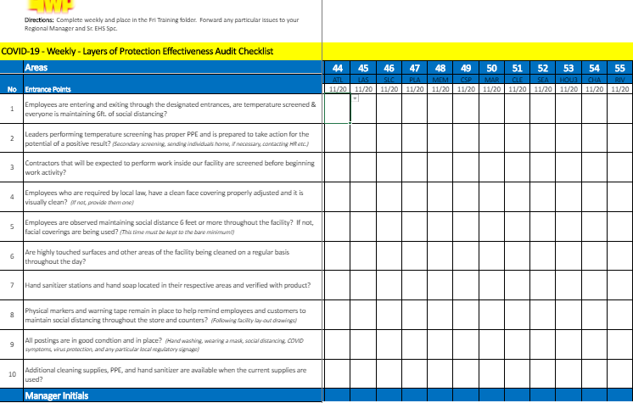
Example 2.5
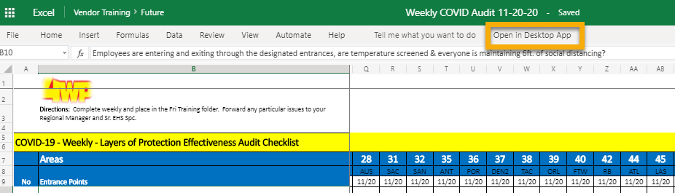

Example 2.6
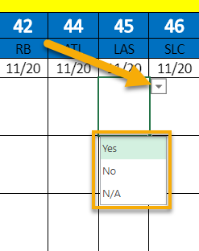

Example 2.7
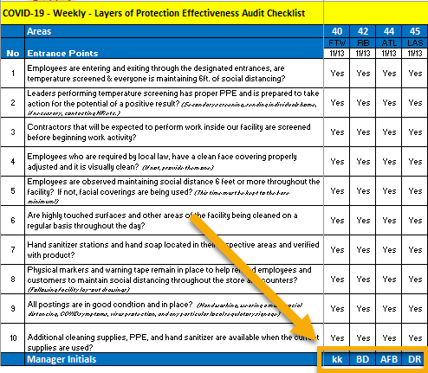

Example 2.8
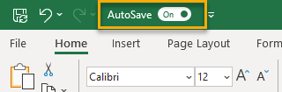

Example 2.9
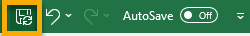
Example 3.1
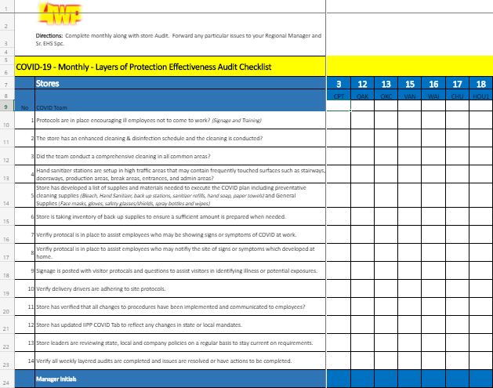
Example 3.2

