Facebook Schedule Suggestions
Monday: Post a game or giveaway to get people engaged and active. Make sure in the post we are asking customers to be engaged. Examples: Like this post, comment on this post, tag a friend, share.
https://www.postplanner.com/facebook-timeline-contest-ideas/
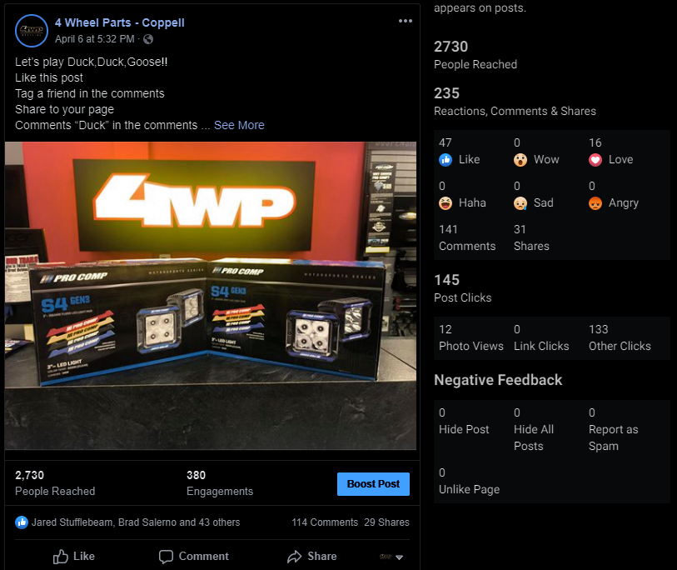
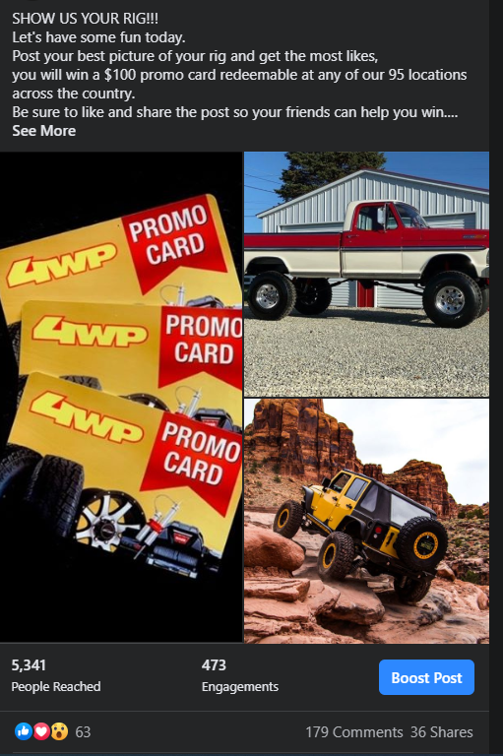

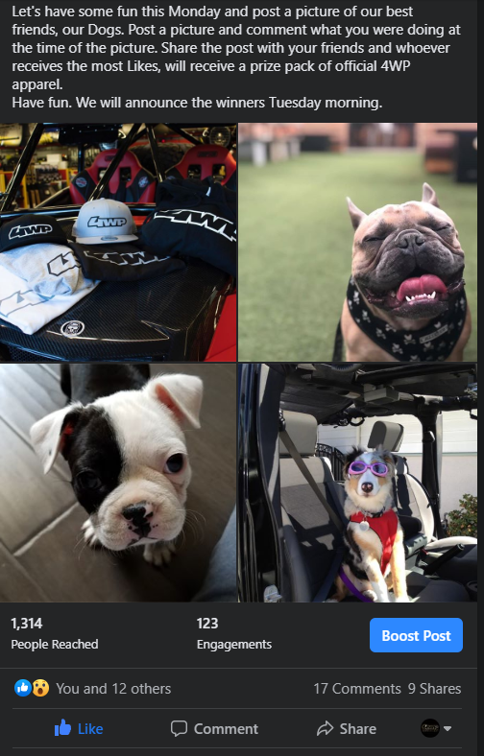

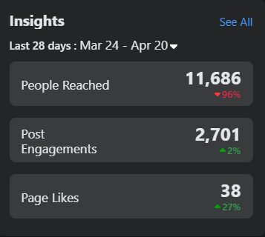

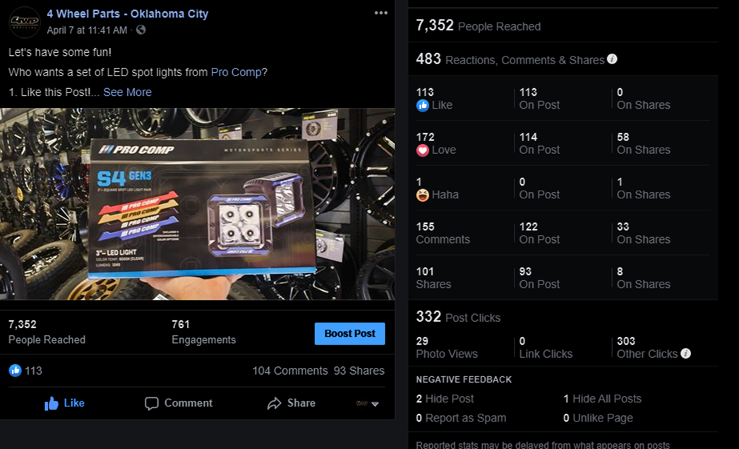

Tuesday: Highlight a product- preferably TMG. Use a post from our brands and make sure there is a link to our website. You can also use this spot to post a video of someone at the store with a great personality to help highlight it.
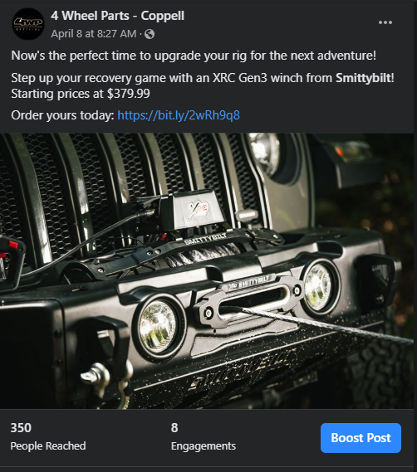

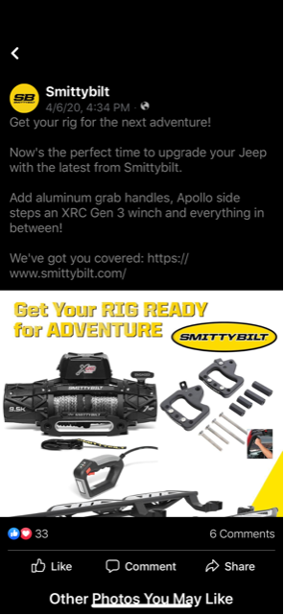
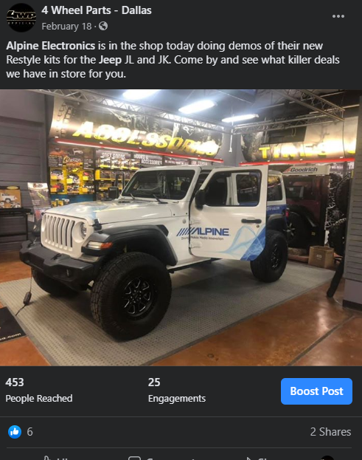

Live videos and instructional videos are great. People like watching videos over pictures.
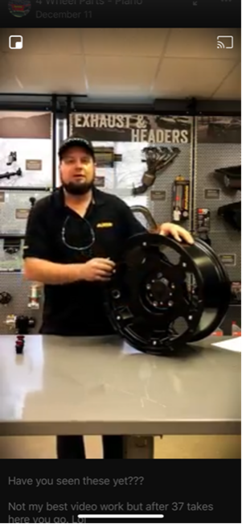

Wednesday: Customer Spotlight. Post a picture of a customer’s rig. Make sure you tag that person, so proper credit is given

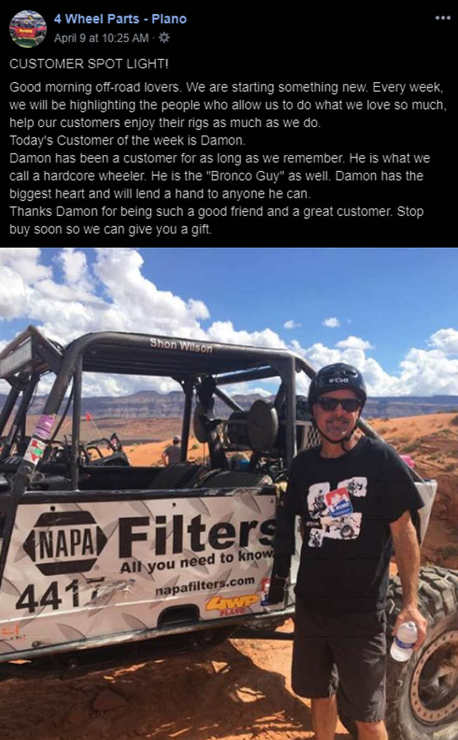

Thursday- Post a good review that a customer has given the store. Make sure you mention that customer and explain how excited we are that they gave us a great review. Make sure we are asking customers to leave reviews on social media. The more positive reviews we get, the better chances we have at drowning out any negative reviews. We are starting to see more reviews in the stores now that are using this post.

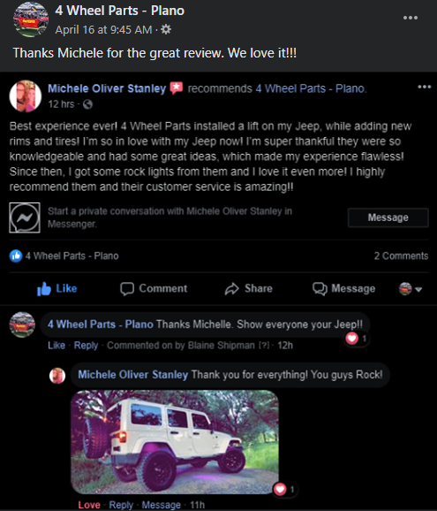

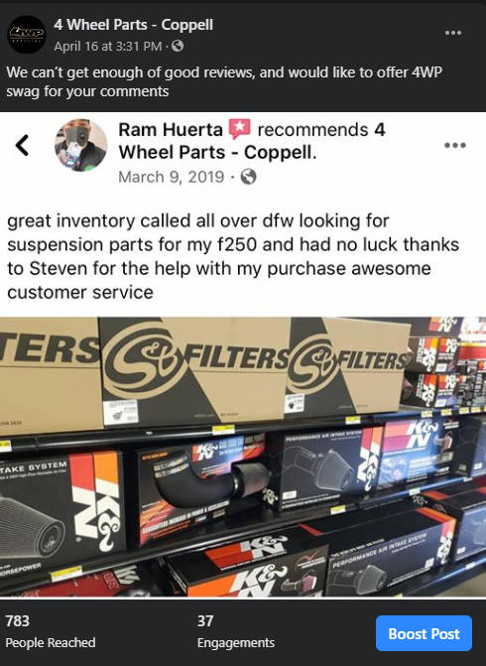

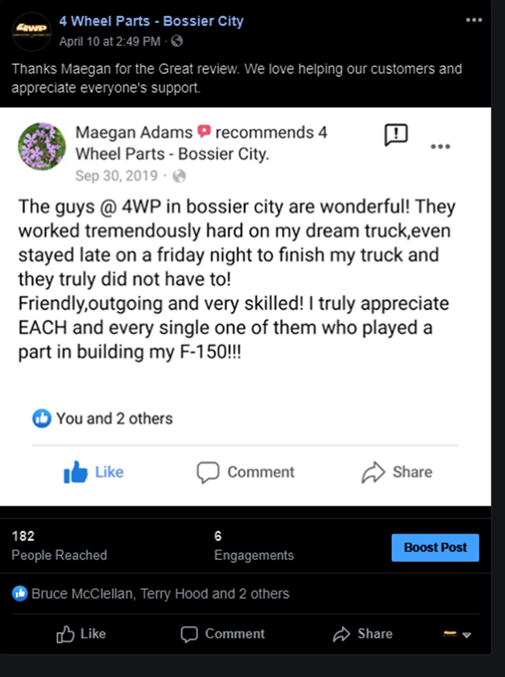
Friday- Highlight the Dirt. They have some great articles. If there is not a new one, use a blog or vendors write up on a product. Also, you can post a how-to video.

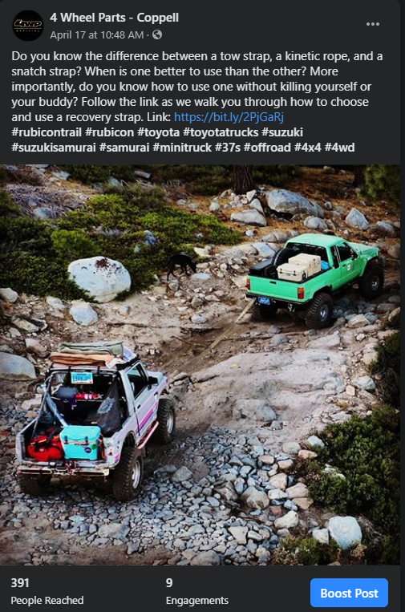
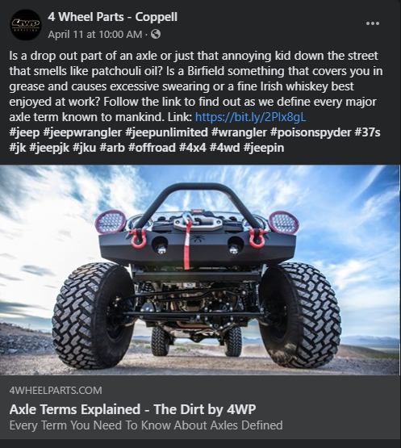
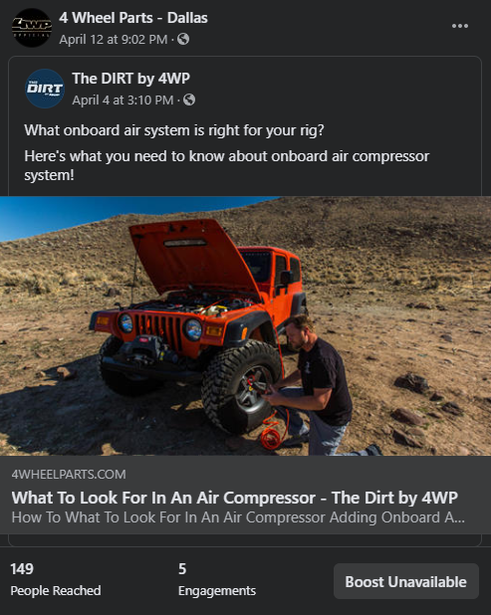
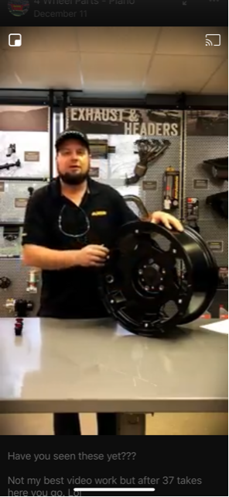

Saturday: Use this day to highlight a build in the shop you did during the week. Make sure you get a great picture with plenty of light and make sure the picture is clear. I-Phone has a great feature on the camera called “Portrait Mode”. You want to make sure you tag any brands and explain clearly what you have done. Make sure we always spell check as well.
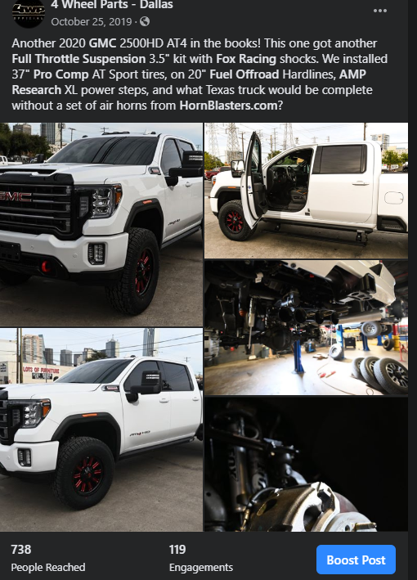

We want to continue to post corporate pictures and specials. We also want to make sure we post something other than ads. We want to keep our customers engaged and stay relevant. TMG is starting to step up and provide great pictures and videos. Make sure we are using these to our advantage and tagging the brands we are highlighting.
You can also post funny posts and Meme’s. Please be respectful though.

Think about posting in Spanish as well. If you cannot make one, use another store that has posted one in Spanish to help reach this demography.

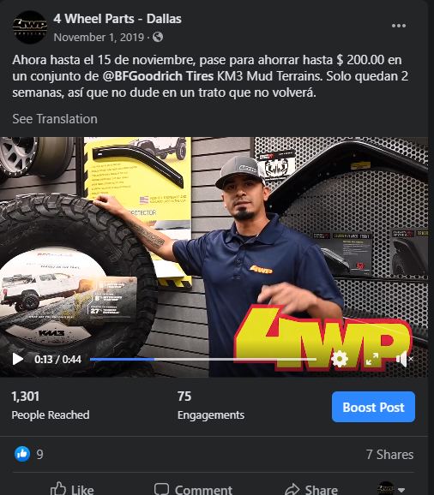

We must stay engaged and post daily. Use this guide to help you with your daily posts. You do not have to go day by day but just make sure you are posting on all your social media platforms daily. Check out this great article on how to keep your customers engaged. https://www.postplanner.com/facebook-post-ideas-for-businesses-that-guarantee-engagement/

We are tracking to make sure all corporate posts are up in time. Make sure you get cover photos, posts on Facebook and don’t forget Instagram up by the time it is requested from corporate. This should be the easiest post of the week since corporate supplies everything for you. Don’t forget to stay engaged with the comments and private messages.

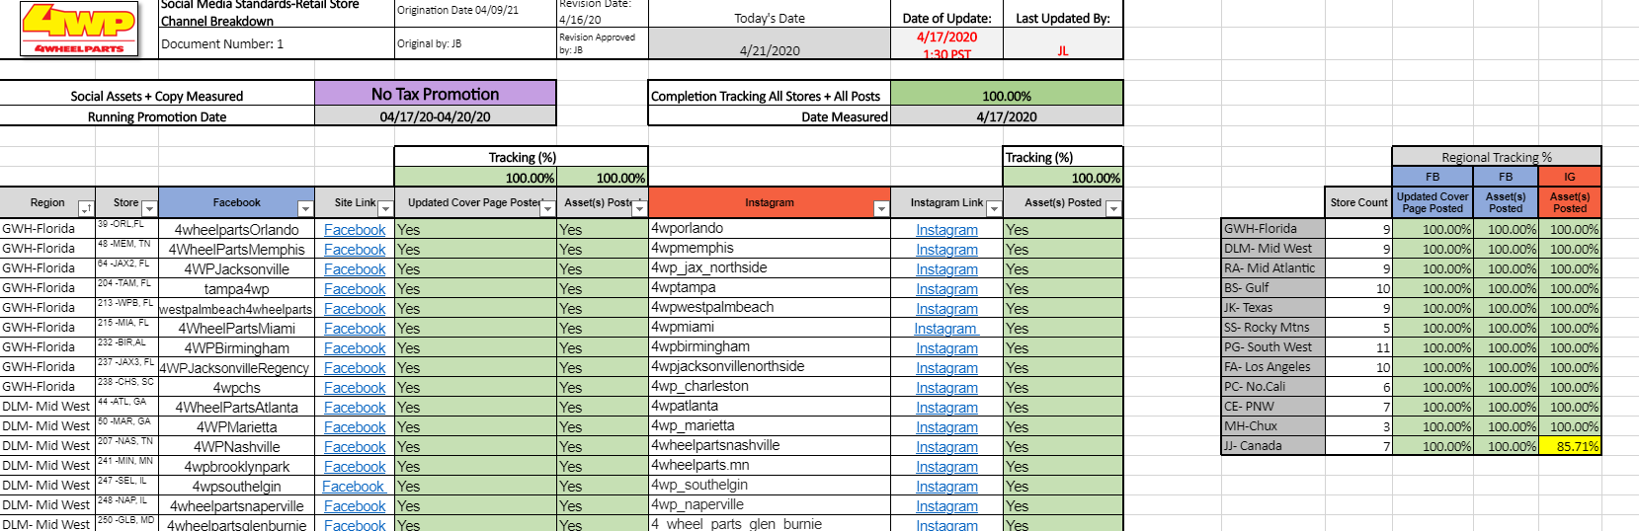
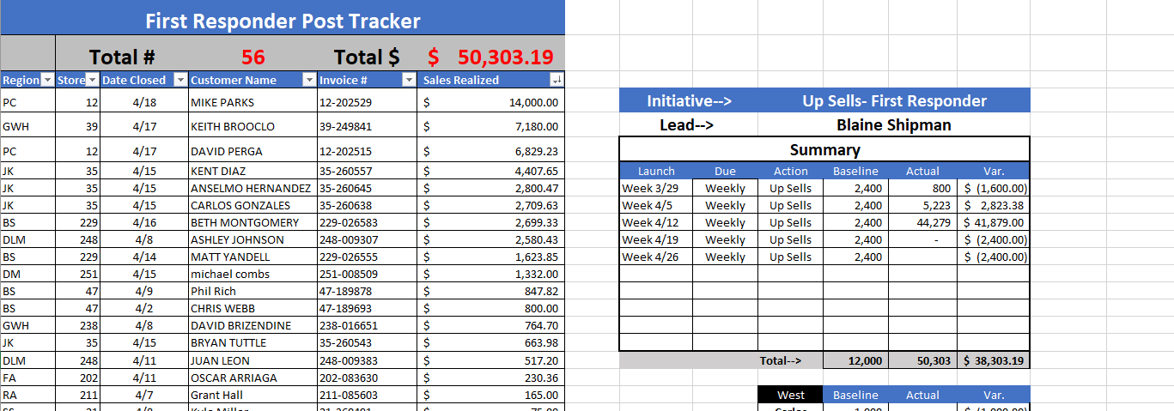

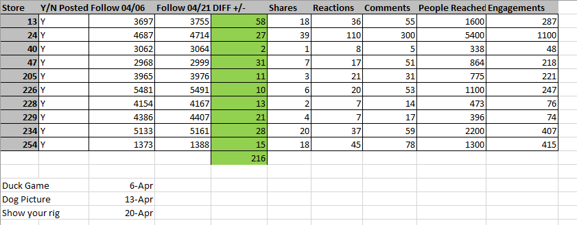

Results for Show us your rig post on 4/20. In all the region has 216 new followers in 3 weeks’ time.

The goal is to get more followers so when we do run ads and promotions, we are reaching our customers

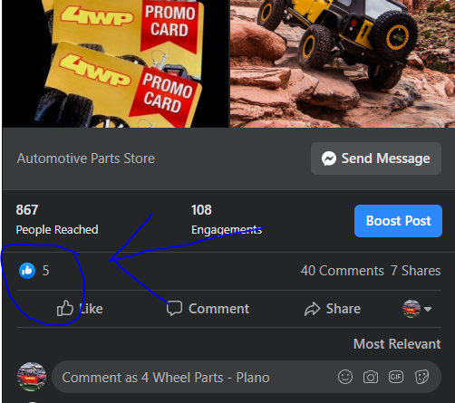
This shows how to invite people to follow and like your page.
